

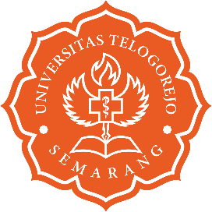


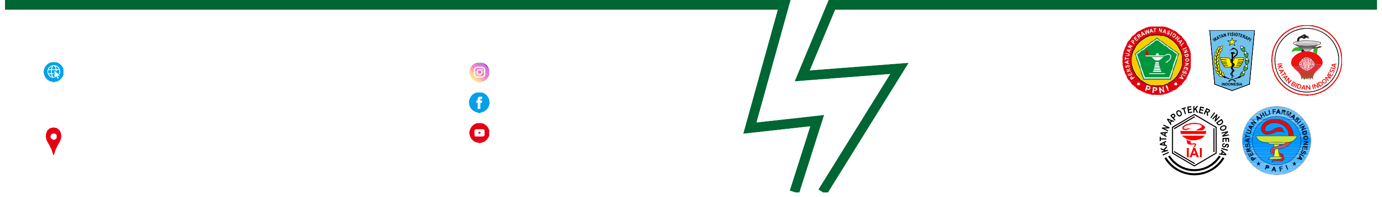

OFFICIAL WEBSITE
www.universitastelogorejo.ac.id

OFFICIAL ADDRESS
Jl. Puri Anjasmoro / Jl. Yos Sudarso Semarang Telp. (024) 76632823, 76632824, 76632825

OFFICIAL SOSIAL MEDIA
@universitastelogorejo.ofuniversitastelogorejosmg
@universitastelogorejosemarang

SUPPORTED BY :

